**Md. Maruf Rayhan**

**Reg: 232-35-623**

**Id: 0242320005341623**

**Section: 41-J2**

**Assessment – 04**

**Date: 20.09.2024**

**Question - 01:** ***Count the number of vowels in the string.***

**Code:**

**#*include* <stdio.h>**

**int *main*()**

**{**

**char str[100];**

**int vowels = 0;**

***printf*("Enter a string: ");**

***gets*(str);**

***for* (int i = 0; str[i] != '\0'; i++)**

**{**

***if* (str[i] == 'a' || str[i] == 'e' || str[i] == 'i' || str[i] == 'o' || str[i] == 'u' ||**

**str[i] == 'A' || str[i] == 'E' || str[i] == 'I' || str[i] == 'O' || str[i] == 'U')**

**{**

**vowels++;**

**}**

**}**

***printf*("Number of vowels: %d", vowels);**

***return* 0;**

**}**

**// *Author: Md. Maruf Rayhan (623) :D***

**Attachments:**

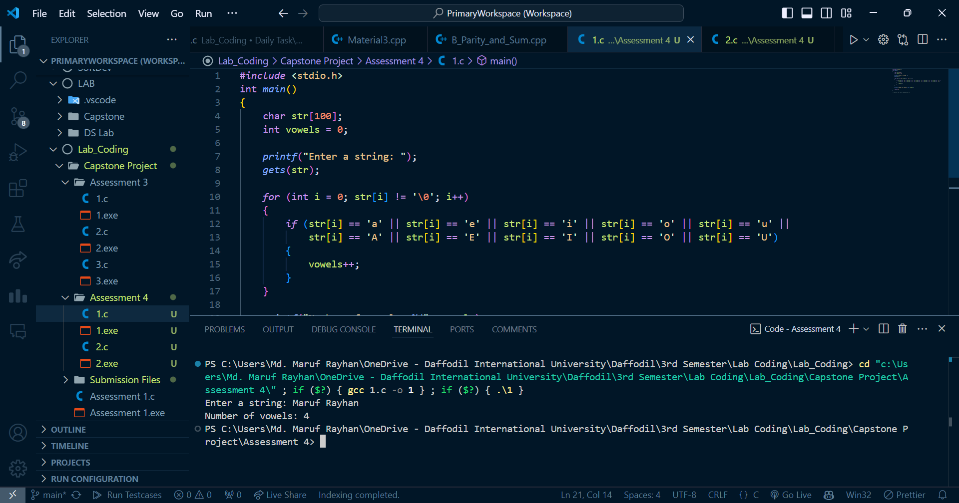

**Question - 02:** ***Reverse the string without using any built-in functions.***

**Code:**

**#include <stdio.h>**

**int main()**

**{**

**char str[100];**

**int i, j, temp;**

**printf("Enter a string: ");**

**gets(str);**

**for (i = 0, j = 0; str[j] != '\0'; j++)**

**;**

**j--;**

**while (i < j)**

**{**

**temp = str[i];**

**str[i] = str[j];**

**str[j] = temp;**

**i++;**

**j--;**

**}**

**printf("Reverse string: %s", str);**

**return 0;**

**}**

**// Author: Md. Maruf Rayhan(623) :D**

**Attachments:**

